Directions: The goal of the following problems is to help challenge and deepen your understanding of the current topic. Don’t assume that you will know how to answer every question. You will work with at least two other students in the class to try and find solutions and write arguments for each of the following questions. Be sure that you question your classmates’ reasoning. If you don’t understand how they are getting something, you should ASK THEM TO EXPLAIN! Being able to defend your reasoning is important and so you are actually helping them by asking them to explain.

Challenge Questions

- Evaluate the integral using a trigonometric substitution.

Let , where , then

We must now write our solution in terms of x. Since and due to the angle restriction, we can say that . We can construct the following reference triangle for (Note: this triangle is the same in the first and fourth quadrants) is:
x

From the reference triangle we see that and therefore

- Instead of using a trigonometric substitution, evaluate the integral using simple geometry.
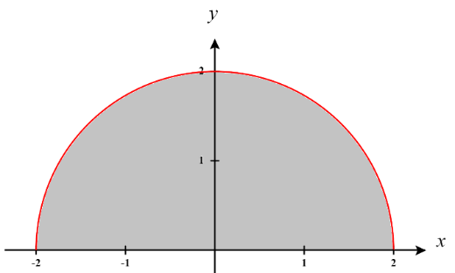
Notice that function being integrated is which is the top half of a circle of radius 2 centered at the origin. See the picture shown below.

Therefore, the area of the region is given by .

- Suppose that and . What is the value of ?

We see that
We need

This implies that
So,
Since we have
Therefore .
So, .

- Evaluate the integral .

We need to start with a polynomial long division.
This means that
We see that
We need

We add the two equations together and get and this implies that .
So,

- Evaluate the integral

We see that
We need

The last two equations imply that and this, when paired with the first equation implies
So,
For the second integral let and . This implies

- Evaluate the integral . (Hint: Try the substitution )
Let and . Therefore,
We see that
We need

This implies that
So,

- Consider the function where and n is a positive integer.
- Setup up what the partial fraction decomposition of look like. You do not need to find all numerators.

We know that .

- Determine the numerator for fraction with as its denominator.

Part (a) implies that .
If then,
- The Weierstrass substitution is a technique for transforming a rational function of trigonometric functions into a rational function of t. It is named for the German mathematician, Karl Weierstrass, who is often called the father of modern analysis. Below is the substitution:

, where

- Use a geometrical or analytic argument to show that under this transformation. (Hint: use some double angle identities on ii & iii)
We see that if , then .
If we then take the derivative of both sides we obtain

Since we know that and therefore can set up the following right triangle based on the fact that . (Note that the triangle below is the same regardless if it is drawn in the 1st or 4th quadrant.)
From this we see that the hypothenuse of the triangle is .
We know from double angle identities that and therefore .

We us the triangle from part (ii) again here.
We know from double angle identities that and therefore, .

- Use this technique to evaluate the following integrals.

Now use partial fractions. We see that .
This implies that

We then attempt to solve this system.
Therefore,
We use a u-substitution on the remaining integral.
Let and
Therefore,

Then we replace t based on our original substitution and get

